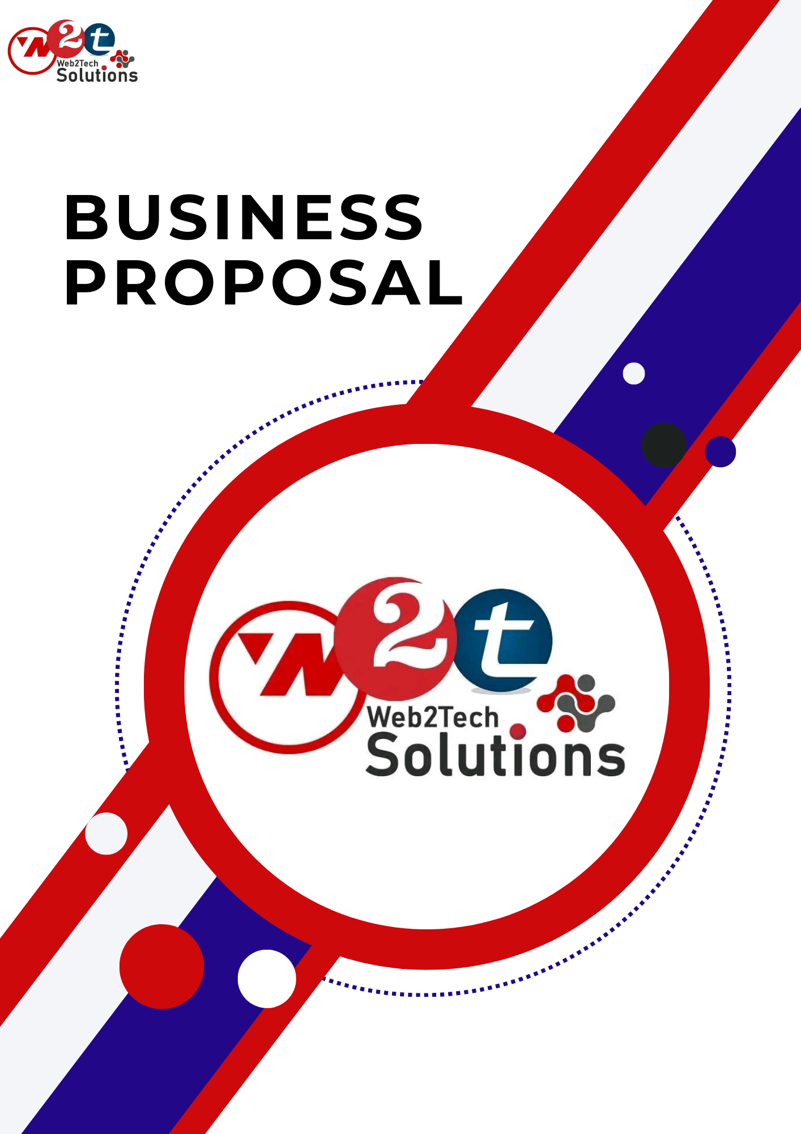*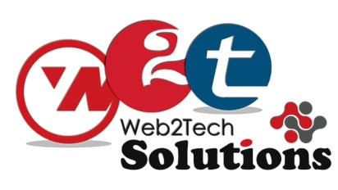*

**Dear sir,**

**Greetings of the day !!!**

Thank you for showing interest in our earlier conversation.

**We are the world's largest IT Company to grow their business Domestic & internationally. We have Million Registered users coming from 100 countries across the Globe. Web2tech can also help you to get better exposure for your products in the international market as it is the 1st choice of buyers internationally.**

Thanks for your precious time as per our earlier conversation regarding **Online Business inquiry or Big Business Website & company Promotion** in all search engines, so we are offering in this proposal we will promote **your product separate keywords** on top pages of [Google](http://www.google.com/), [Yahoo](http://www.yahoo.com/), Msn, Aol, rediffmail like all the 254 Major Search Engines. So please go with my mail & get back to me as soon as possible.

**🌟 National Level** - **Going Globally: Expand Your Business Nationally**.🌟

                  Online Business Proposal Cost **Rs.12'000/-+18% G.S.T**for Dynamic website unlimited pages with images + Admin Panel for a lifetime + SEO Promotion Globally  + SMO + Email-Marketing internationally + International business Listing + Business Classified postings

                 [whole services for 1 years]

**In This Proposal, You Will get:-**

1).Individual Domain Like :[www.yourcompanyname.com](http://www.yourcompanyname.com/" \t "_blank)  
2).POP emails id like :  [info@your-company-name.com](mailto:info@your-company-name.com)  
3).Dynamic customize Website with admin panel.  
4.)SEO Promotion.  
5.)Social media Widgets.  
6.)Video promotion.  
7.)Free Technical Support.

8) Search engine optimization.

9)Business classified Posting.

10)National business listing.

11) Email marketing in your targeted area .

12) Enquiry panel

13)WhatsApp api

**DYNAMIC CUSTOMIZE WEBSITE FEATURES**:-

1.Website Designing: Your website would be designed according to you and your products/Services or company profile.

– Website Version: CORE PHP

-Compatible all Browsers and Mobile Responsive/friendly.

2.Website pages: Unlimited pages according to your requirement Other Important Pages like Home Page, About Us, Gallery, Contact Us and video Tab.

3.Website Product page: Unlimited Products/Services, Images with specific content.

4.Inquiry Form: We will make an inquiry form from where you will get inquiries through the client-side.

5.Business Inquiry: You will get business inquiries Through the website.

5.Website Copyright: All Rights will be reserved for your company.

6.Update your web pages and their content frequently so that your website reflects recent events or current trends.

7. Free Technical Support: During your membership tenure a dedicated support executive will support you to maximally utilize all the services available in membership. (24\*7) T&C-if your company isn't verified online through Google internet corp. then we will verify your company and you need to pay additional costs.

8. Google promotion: We will promote your website with your product Separate keywords on Google's top page through SEO

9. Renewal cost: Next year Renewal costing only 5000/- Rs. in this renwal for In this renewal, we give you domain hosting for 1 year. And AMC And Techincal support include.

**Dynamic Admin/Control Panel Features:-**

1). Manage Home Page Content And Flash

2). Manage Other CMS Pages Content

3). Manage Categories/Products Pages

4). Manage Hot/Featured Products

5). Manage Contact Information

6). Manage Our Clients Page

7). Manage Client Testimonials Page

8). Manage Career/Current Jobs Opening Page

9). Manage Company News Page

10). Manage Company Videos Page

11). Manage Company Photo Gallery Page

12). Manage Meta Tags (Title, Description And Keywords)

13). Social Media Follow Us Links

some external features also like :-

1) Google map in member folder

2) 41 Language converter   
3) Window search bar   
4) zoom facility in website images   
5) Link on Facebook, Twitter, MySpace, LinkedIn

Our Approach in SEO (Search Engine Optimization)Our experts achieve higher rankings quickly by employing all the following elements of a comprehensive search engine optimization,SearchBookmarking/Management,Link Building Campaign,Manual Directory Submission,Local Directory Submission SUBMISSION , REGISTRATION , MONITORING , POSITIONING Etc.

SMO - Social media optimization  
Social media optimization (SMO) is the process of increasing the awareness of a product, brand or event by using a number of social media outlets and communities to generate viral publicity.  
  
Social media optimization includes using RSS feeds, social news and bookmarking sites, as well as social media sites and video and blogging sites. SMO is similar to SEO (search engine optimization) in that the goal is to drive traffic to your Website.

**Steps We Follow**

Website Analysis and Evaluating Competitors Progress

Setting Goals: Our aim is to provide you with complete web marketing solutions to help your website rank high on the search engines. Before moving on further, we will have a consultation phase where we will discuss what your website goals are and how we can accomplish them. In addition, we may ask you certain questions that may be concerning the website structure and strategic foundation for your social media marketing. Our team is here to give you only the best SEO services and quality at its best.

Competitor Benchmarking Analysis: There are many factors that help us to understand your competition's SEO benchmarking. By using our SEO services you will be able to receive a branded presence on Google and Yahoo search engines. The upstream and downstream traffic will be aggressively monitored by our SEO professionals. The Social media presence will improve and you will start to enjoy the online audience a whole lot more than before.

Key phrase Research: We do a lot of research regarding the use of keywords and we also look at what kind of keywords your clients are using in order to gain traffic. We use significant high traffic keywords that your rival does not know about.

On-Page | Off-Page | Social Media Optimization

On-Page Optimization:

We incorporate your selected keywords into existing internet pages with keyword saturation and density which is needed to achieve the top 10 rankings by modifying and optimizing the crucial areas in your site’s source code. The accurate implementation of server levels adjustments will guarantee your site to be user friendly. Here’s what will happen after applying all the above-mentioned points:

|  |  |
| --- | --- |
| **XML Sitemap Creation and Submission** | **Title Tags Optimization** |
| **Text Sitemap Creation and Submission** | **Description**  **Meta Tags Optimization** |
| **RSS Feed Creation and Submission** | **Keyword Meta Tags Optimization** |
| **Robots.txt File Creation** | **Canonical Tags Optimization** |
| **Google Submission and Verification** | **Hreflang Tags Optimization** |
| **Bing Submission and Verification** | **Heading Tags Optimization** |
| **Google Map Listing URL** | **ALT Tags Optimization** |
| **Google Webmaster Account** | **Hyperlink Optimization** |
| **Bing Webmaster Account** | **Text Navigation Links** |
| **Google Analytic Account** | **Search Engine Friendly URLs** |
| **Google Local/Map Account** | **Update Copyright Year** |

**Our exact SEO Process we follow**

**1 (step) Optimizing your site:** we will work for you in optimizing your web site for top rankings on Google, MSN, Yahoo, AOL and other major Search Engines.

 This process includes:

1. Keyword Research                   √

2. Optimizing your web site          √

3. Analyzing keyword density       √

**2 (step) Get your site listed:** we help you get ranked in every major search engine, directories and special web sites that relate to you business

This process includes:

1. Manual Submission to Search Engines   √

2. Search Engines Auto Submissions        √

3. Improving Link Popularity                    √

4. Directories manual submissions            √

**3 (step) Track your results:** we will track the results and create custom reports about your search engine optimization, ranking, and many more

      Our SEO services use only ethical search engine optimization techniques. We use only practices that turn out into lasting results in search engines.

Our Approach in Search Engine Optimization

Our experts achieve higher rankings quickly by employing all the following elements of a comprehensive search engine optimization campaign.

 OPTIMIZATION

• We optimize the content of each of your web pages.   
• We optimize the HTML code of each web page.   
• A Custom Keyword analysis showing the popularity of your selected keywords.   
• We optimize the meta-tags and inset them on each page.

**SUBMISSION**

• We submit your site to each search engine and directory manually.   
• We follow each individual search engine's submission protocol and guidelines.   
• We submit to the top search engines and directories as often as every two weeks depending on the protocol for each individual search engine and directory.

**REGISTRATION**

• Registration with the promotion of web site in top pages in popular Search Engines (more than 10+ search engines) which generates 90% of the global search traffic like Alta Vista, Hotbox, Lycos, Yahoo, WebTop, All the web, Google, Yahoo, Rediff, MSN, Lycos, Alta-Vista, Hakia, Alexa, etc with 10 Key Words.

**MONITORING**

• Evaluation of traffic reports for search engine activity.   
• Evaluation of ranking reports.   
• Monthly reports with the keywords and their status.   
• We e-mail you a copy of the reports monthly.

**POSITIONING**

• We work hard to get as many of your keywords into the top 20 results for each of the Top search engines, like Google, Yahoo, Rediff, MSN, Lycos, Alta-Vista, Hakia, Alexa, Bing, Hotbot, Aol, Yandex etc.

• Once a keyword is in the Top

 5

 we will take any necessary actions to react to a drop in the rankings.

• This is done on a weekly basis since the search engines change so often.

**Off-Page Optimization:**

We are responsible to establish your positive "Online Reputation Management" which is also known as Off-Page Optimization. Whether it’s creating your website's profile on Facebook, LinkedIn, Twitter and Google+, etc. or blogging your heart out to gain higher SERPs (search engine results pages), we are here to help you out. Some of the other Off-Page Optimization techniques are:

**Social Media Optimization**:

One of the toughest things within web marketing is recognizing the right type of link building. Obtaining a massive number of relevant referral links has become the most important point of today's web marketing strategy. The ideal mixture of link building options will be selected to craft and customize a link building plan for long run ROI success and high ranking results. Our tactical methods include:

**Benchmarking | KPI Results**

**Monthly Benchmarking Report**

In this report, you will be able to see your existing listings in all the major search engines. This brief and concise report will be sent on a monthly basis to help you to document your website progress. Our analysis report will show you how your website is suffering from major search engine compatibility issues and the reasons why it is not ranking high on the target search engine queries.

**Monthly Key Performance Report (KPR)**

Each month we will be sending you a ranking report based on the progress of your website on the search engines and sending it to you via your email. The rank report will include rank reports showing your website’s position on Yahoo, Google, and Bing.

We'll let you know which keywords bring current traffic.

**Results**

Since there are search engines that tend to index or re-index the optimized site in 4-12 weeks, however, there are search engines like Google that help your website to crawl more frequently and reach higher than ever before. You can expect to see results starting to appear right in front of you after 4-6 weeks of submission from our side. Indexing and reindexing tend to take time to settle down but they usually stabilize after two months.

In the meanwhile, your traffic rises continuously since we will make your website visible more and more on the search engine index and locate more of your website's optimized pages.

**Terms of Service**

**White Hat SEO Techniques**

We only implement White Hat SEO techniques which are recommended by each search engine. We encourage our clients to use valid SEO practices that are mentioned in the Webmaster guidelines.

**Requirement from client**

Website Access like Hosting details or FTP  
Social Pages login details

**Our Responsibility**

·         Monthly reporting

·         Ranking updates

·         Monthly Ranking improvement.

·         We are very secure towards our clients with every detail and data. After completing all the work we return all website                 details of the client.

·         We don’t use the client any details of id for personal use... It should be only for client work

·         We are very aware of our work and time.

·           Any other requirement or features on your website are chargeable.

Sir, I hope this proposal will lead us into a new business arena thus building a long term relation with the companies .

Waiting for your positive reply.

--

**Saurabh Mishra**

Team Manager, Web2tech Solutions

73034 07586 [|saurabh.web2techsolutions@gmail.com](mailto:|saurabh.web2techsolutions@gmail.com)

Rz-17, 3rd Floor, Main Najafgarh Road, Nawada,

Metro Pillar No-716, New Delhi-110077

[Social icon](http://www.facebook.com/web2techsolutions/)[Social iconSocial icon](http://www.linkedin.com/in/web2tech-solutions-5a1625174/)[Social icon](http://twitter.com/Web2techS)[Social icon](http://www.youtube.com/channel/UC-27ZqUHbtkmSJih8gc-SYw)[Social icon](http://in.pinterest.com/web2techsolutions/)

|  |  |  |  |
| --- | --- | --- | --- |
|  | |  | | --- | |  | |  | |

**